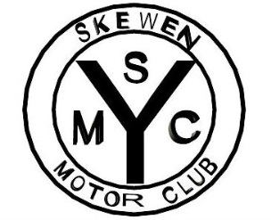
SKEWEN MOTOR CLUB
CLASSIC & VINTAGE SHOW
AND FAMILY FUN DAY
Sunday 7th August 2022
Gnoll Country Park Neath
We would like to invite you to our Annual Show at The Gnoll Country Park in Neath The show is approximately 3 miles from the M4 junction 43. Just follow the signs for Neath town centre, then follow the SMC arrows up to the park.
Exhibitors will enter the park via the Cimla Road entrance.
Will all entrants please be on the field by 10am Thank You
For all SAT Nav users the postcode is SA11 3BS
Preferred category, Car, Commercial, Motorcycle etc. …………………………………………………………...
Owners name …………………………………………………………………………………………………………………………..
Address…………………………………………………………………………………………………………………………………….
………………………………………………………………………………………….. ……………………………………………………..
Post code …………………………………………………… Telephone number……………………………………………
Make…………………………………………………………… Model………………………………………………………………..
Year……………………………………………………………… Reg No………………………………………………………………
Club stand: YES / No State Club……………………………………………………………………………………
Please Note:
- I understand that my property will be brought to the show entirely at my own risk.
- I confirm that my entry will have as a minimum 3rd party insurance cover.
- Skewen Motor Club, or The Gnoll Country Park will Not accept any liability for any damage howsoever caused to any vehicle or property on the showground or in transit
- No vehicle shall be allowed to be displayed for advertising, profit or gain.
- Skewen Motor Club have the right to refuse entry to any person or vehicle on the day.
- No loud music is to be played whilst on the showground.
- BBQ’s and any naked flames are prohibited on the showground
Failure to adhere to any of these conditions will result in expulsion from the event.
Signed ……………………………………………………………………………………………………….
Send all entries by 4th July 2022 to:- The Event Secretary, Skewen Motor Club, 7 Lupin Close, Port Talbot. SA12 7AR
01639 773662
Late entries on the day will be charged £5.00 proceeds will go to charity.
Please remember to include SAE only one envelope required for multiple entries.
NO SAE NO REPLY

